A Co-Simulation Scalar-Potential Finite Difference
Method for the Numerical Analysis of Human Exposure to Magneto-Quasistatic Fields
Martin Zang¹, Carsten Cimala¹, Markus Clemens¹, Jennifer Dutiné¹, Thomas Timm¹, and Benedikt Schmuelling²
¹Chair of Electromagnetic Theory, University of Wuppertal, 42119 Wuppertal, Germany
²E-Mobility Research Group, University of Wuppertal, 42119 Wuppertal, Germany
A two-step approach for the simulation of the exposure of a human body to magneto-quasistatic fields is presented. The Co-Simulation Scalar-Potential Finite Difference (SPFD) method is a calculation scheme where a distribution of the magnetic vector potential inside the biological tissues is derived from a free space magnetic source field simulation using a tree-cotree gauging algorithm. With the obtained magnetic vector potential the electric field strength inside the voxel representation of the biological tissues is calculated solving a high-dimensional discrete Poisson equation on a high-performance multi-GPU workstation. An exposure scenario including an inductive power transfer (IPT) system, a car model and an anatomical human body voxel model is simulated using this approach and the results are compared to a monolithic Scaled-Frequency FDTD simulation. The maximum body-internal electric field strength (voxel average) is determined and compared to basic restrictions recommended by the International Commission on Non-Ionizing Radiation Protection (ICNIRP).
Index Terms—Low frequency dosimetry, Scalar-Potential Finite Difference method, tree-cotree gauging.

I. Introduction
Magneto-quasistatic fields are excited by low-frequency electric currents and they occur e.g. in the immediate vicinity of inductive power transfer (IPT) systems. When a human body is exposed to a magneto-quasistatic field, electric fields are induced inside the body tissues which superpose with the natural body-internal electric field strengths. Since nerve cells and other electrically sensitive cells are stimulated by electric fields, the International Commission on Non-Ionizing Radiation Protection (ICNIRP) [1] recommends limits for the body-internal electric field strength for providing protection against adverse health effects due to magneto-quasistatic field exposure.
For the simulation of the human exposure to magneto-quasistatic fields different numerical tools are available. The use of a conventional magneto-quasistatic field solver for such a problem might lead to the solution of a high-dimensional and extremely ill-conditioned linear system of equations depending on the complexity and resolution of the exposure scenario model. Simulations of low-frequency IPT exposure scenarios using a commercial FEM-based magneto-quasistatic field solver are presented in [2].
Alternative simulation methods make use of the fact that eddy currents induced inside the exposed human body with low-frequency magnetic field exposure scenarios are small due to the low electric conductivity values of human tissue [3]. Thus, the interaction of these induced currents with the exterior magnetic field can be neglected. This allows to divide the calculation domain (i.e., the magneto-quasistatic field exposure scenario) into two domains by performing the simulations of the magnetic source field and the electric field inside the human body due to an exposure of this field, respectively, in two separated steps.
This effect is e.g. used in the Scaled-Frequency Finite

Difference Time Domain (SF-FDTD) method [4], [5], where the low-frequency problem is calculated at higher frequencies and only the electrical field solution inside the body is scaled back to the original frequency. Here the use of Finite Difference type spatial discretization schemes using tensor-product type Cartesian grids is especially advantageous w.r.t. the available voxel-based body phantoms. For the electric field simulations induced by IPTs operating at frequencies between 80 and 140 kHz a voxel size of 2x2x2 mm³ is prescribed [1].
An alternative two-step approach is used in the original Scalar-Potential Finite Difference (SPFD) method [3], [6], [7], where the magnetic source field is represented by a magnetic vector potential derived from analytic calculations.
A variant of this approach is the Extended SPFD method where the magnetic source field vector potential is calculated with a magneto-quasistatic field solver based on the Finite Integration Technique [8], [9]. This approach allows to consider shielding effects due to highly conductive (e.g. metallic or carbon fiber) materials in the calculation of the field excitation, but is still limited to the immediate availability of the magnetic vector potential source vector.
In order to make use of a magnetic field distribution generated by a coil source calculated without the consideration of a human body model with a black-box magnetic field solver, where a magnetic vector potential not directly available, the approach in [6] was extended within the Co-Simulation SPFD method [5]. Using a magnetic flux density a corresponding vector potential is derived in the designated area of the human body model using a tree-cotree gauging algorithm [10]. This vector potential representing the magnetic source field is then used to calculate the electric field strength inside the body tissues applying the SPFD method where a large scale discrete Poisson equation with up to 10⁸ degrees of freedom has to be solved. As a novelty, here, this linear system of equations is solved with a Jacobi-preconditioned conjugate gradient (PCG) solver on a multi-GPU workstation, which goes beyond the previously defined approach presented in [5].
The paper is organized as follows: In Section II the Co-Simulation Scalar Potential Finite Difference (Co-Sim SPFD) method is introduced. Section III gives details on the numerical linear algebra scheme used for the solution of the large scale discrete Poisson equation and the GPU-based implementation on a high-performance computer. In Section IV the Co-Sim SPFD scheme is applied for the simulation of an exposure scenario including an IPT system, a car and a high-resolution anatomical human body voxel model, followed by a comparison to a monolithic Scaled-Frequency FDTD simulation (Section V) and a conclusion.

II. Co-Simulation Scalar-Potential Finite Difference Method
The Scalar-Potential Finite Difference (SPFD) method [3], [6], [7] is a calculation scheme for the determination of the electric field strength inside a human body which is exposed to a magneto-quasistatic field. The approach is used here in terms of the Finite Integration Technique (FIT) [8], [9], [11]. The body-internal electric field strength is calculated using a pre-determined magnetic vector potential of a low-frequency field source. Here, this approach is extended by a co-simulation, where the body-internal magnetic vector potential is derived out of a magnetic field distribution computed by any magnetic field simulation tool.

A. Basic Method
In case of a human exposure with a low-frequency electromagnetic field – when the interaction of the body-internal eddy currents with the exposing magnetic field is negligible – the body-internal electric field strength can be calculated with the SPFD method using the following ansatz:
 | 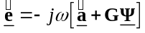, | (1)
where is the vector of the electric grid voltages, is the angular frequency, is the vector which corresponds to the magnetic vector potentials, G is the discrete gradient operator and 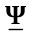 is the vector of the time integrals of the electric nodal potentials. The insertion of (1) into the magneto-quasistatic continuity equation 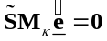 yields the Poisson equation of the SPFD method:
 | 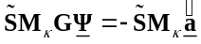. | (2)
Here, is the discrete divergence operator of the dual FIT grid and 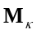 is the constitutive material matrix including the conductivities of the biological tissues.

B. Co-Simulation Approach
The first step of the SPFD method is to obtain a magnetic vector potential inside the body tissues representing the magnetic field of a low-frequency field source. Here, this is done by calculating the magnetic source field without a human body model (with a coarse grid in the designated area of the body model) using any magnetic field simulation tool. The vector of the magnetic vector potentials inside the biological tissues of the exposed human body is derived by applying a tree-cotree gauging [10] algorithm to the correlation
 | 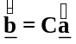, | (3)
where is the vector of the magnetic facet fluxes (interpolated on a fine grid inside the human body model) representing the magnetic source field and is the discrete primal grid curl operator. Since in (3) each component of the magnetic facet flux is assigned to four components of the magnetic vector potential (curl operation around one facet of the primal grid, Figure 1 a), (3) is an over-determined system of equations. By applying the tree-cotree gauging technique, every component of is assigned to only one component of and all remaining components of are set to zero, as shown in Figure 1 b) for two facets of the primal grid. By doing this operation for every facet of the primal grid, the vector of the magnetic vector potentials is obtained. 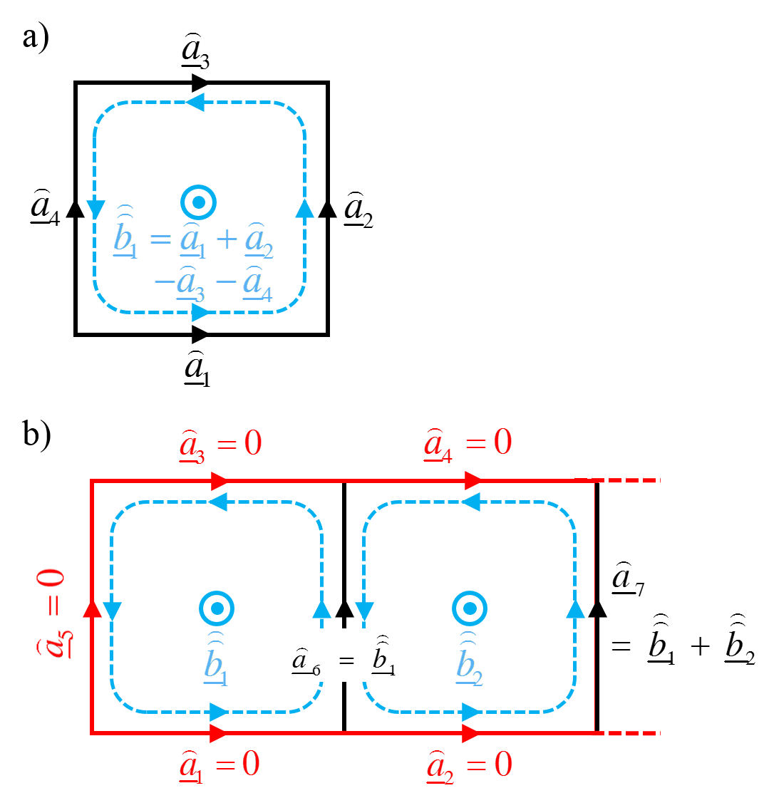
Fig. 1. a) Curl operation for one facet of the primal grid b) Calculation of the magnetic vector potentials out of the magnetic facet fluxes for two facets of the primal grid using the tree-cotree gauging technique
Now, equation (2) is solved to obtain where the electrical conductivities of the biological tissues (represented by 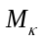) now have to be considered. Insertion of and into (1) yields the vector of the electric grid voltages inside the body, where the body-internal electric field strength can be derived from.

III. Solution of the Discrete Poisson System of Equations
Applying the Co-Simulation SPFD method for the simulation of the magneto-quasistatic exposure of high-resolution human body voxel models includes the solution of a large linear algebraic system of equations (2) with up to 10⁸ degrees of freedom. Since solving such a linear system of equations is very time and memory consuming, a parallelization of the solution process on CPUs or GPUs is appropriate as a calculation speed up can be reached. Furthermore, an extension of the maximum problem size can be achieved by extending the number of the involved processing units (and thus the available memory). Here, as a novel extension of the approach presented in [5], the linear system of equations (2) is solved with a Jacobi-preconditioned conjugate gradient (PCG) solver [12] implemented and parallelized on a high-performance workstation with a NVIDIA Tesla K80 GPU accelerator comprising two onboard GPUs each with 12 GB memory. Given the number of degrees of freedom of the discrete problems and the 24 GB of the GPU card memory limitation, the use of a computationally more efficient algebraic multigrid preconditioner [12] is not yet feasible.

IV. Numerical Example
As an application example for the Co-Simulation SPFD method, an exposure scenario is modeled where a human body model is exposed to the magneto-quasistatic field generated by an inductive power transfer (IPT) system which is positioned below a car model (Figure 2).
An inductive power transfer (IPT) system consists of two coils. The induction (primary) coil is driven by an alternating current with frequencies of 80 up to 140 kHz. This coil is coupled with a pickup (secondary) coil via an airgap (here: 129 mm) to enable a charging process of the electric or hybrid electric car’s battery with a power of up to 20 kW. Figure 3 shows the arrangement of the IPT system. Here, the coils are modeled as perfectly electric conducting (PEC) loops with a radius of 249 mm. Ferrite stripes (purple, µr = 2000) and a shielding plate (blue) with a conductivity of 3.7∙107 S/m are positioned below the primary coil. Additional ferrite stripes are positioned above the pickup coil. In the shown simulation, the induction coil is driven by an alternating current of 144 A (peak) at a frequency of 140 kHz.
The body of the car is composed of thin carbon sheets with an electric conductivity of 7,000 S/m. The human body model (“Duke” [13]) is a discrete voxel model composed of 77 different biological tissues each with specific electromagnetic material properties.
The exposure scenario shown in Figure 2 is simulated using the Co-Simulation SPFD method. At first, the electromagnetic field generated by the IPT system is simulated including the shielding effects of the car body sheets but without the human body model using CST Microwave Studio [14]. The model is discretized with about 324 mio. FIT mesh cells. (Alternatively, any other suitable magneto-quasistatic solver could have been used within the Co-Sim SPFD method.) The distribution of the magnetic field strength is shown in Figure 4, where the designated position of the body model is indicated.
The magnetic field strength is now read out on a fine grid with an edge length of 2 mm and the vector of the magnetic

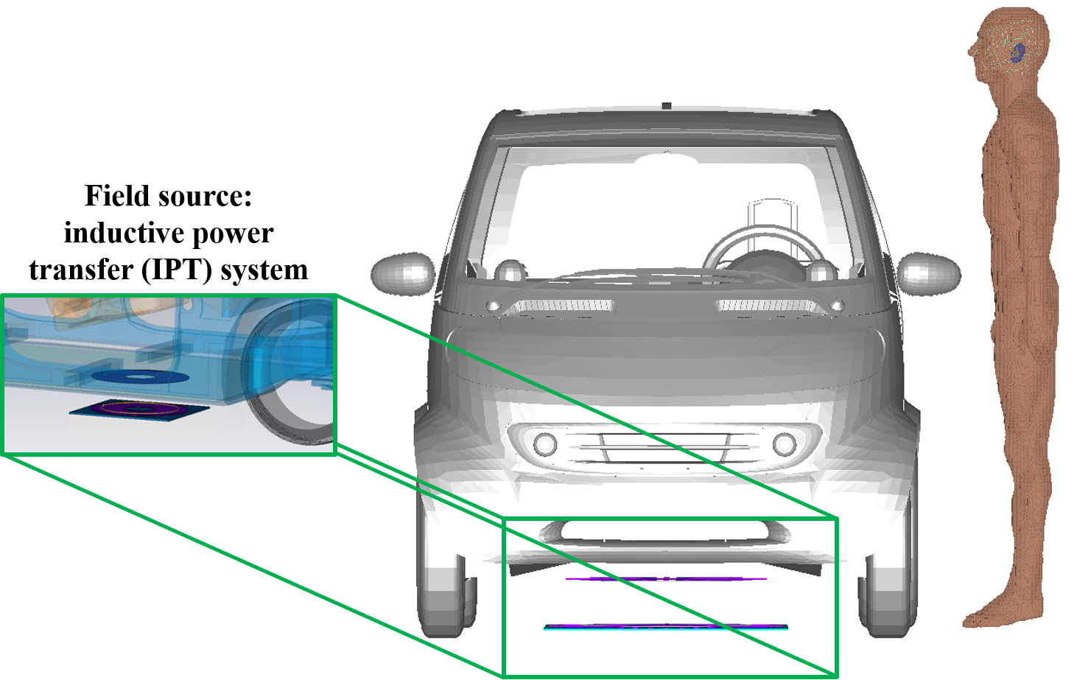
Fig. 2. Inductive power transfer (IPT) system positioned below a car model and a human body voxel model standing beside the car.
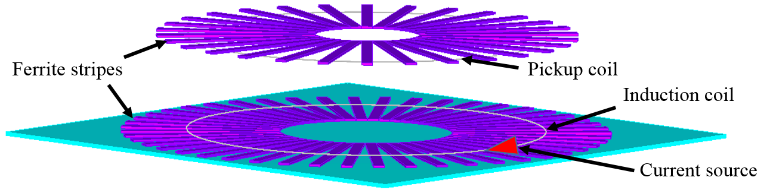
Fig. 3. Arrangement of the coils, ferrite stripes (purple) and the shielding plate (blue) in the IPT system and position of the current source driving the induction coil
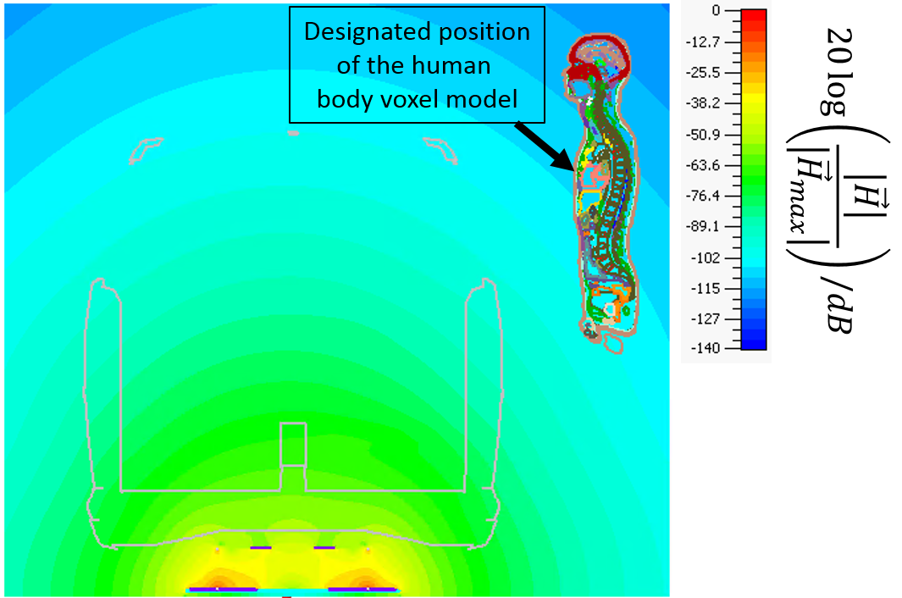
Fig. 4. Magnetic field strength generated by the IPT system in a cross section of the car model with the designated position of the human body voxel model indicated in the field plot
facet fluxes is calculated in the area of the human body voxel model. The vector of the magnetic vector potentials is derived from the magnetic facet fluxes using the tree-cotree gauging technique as outlined in Section II. B. In the next step, equation (2) is setup which results in a linear system of equations with about 8.9 mio. unknowns. This high-dimensional system of linear algebraic equations is solved with the parallelized Jacobi-preconditioned CG solver described in Section III using a simulation time of 6 min. As a result the distribution of is obtained. Insertion of and into (1) yields the vector of the electric grid voltages and thus the body-internal electric field strengths. Figure 5 shows the distributions of the body-internal electric field strength in a frontal plane and in the median plane of the body model.
For the assessment of the exposure the body-internal voxel-averaged electric field strength is determined whose maximum value is 0.683 V/m which corresponds to about 3.4% of the basic restrictions for general public exposure (1.7% for occupational exposure) given by ICNIRP.
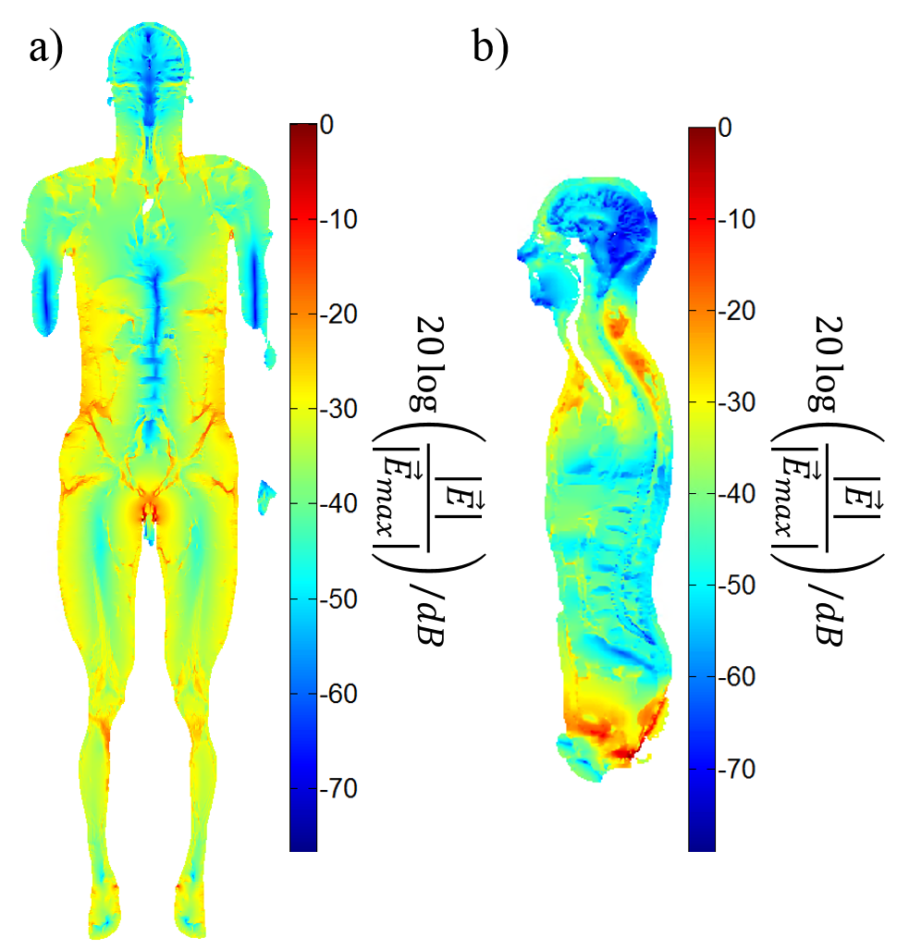
TABLE I
Memory Demands For the Shown Simulations
Monolithic Scaled-Frequency FDTD simulation with CST MWS | Co-Simulation SPFD method
~ 356 GB | Source field simulation with CST MWS:  ~ 129 GB
~ 356 GB | Exposure simulation with CG solver and Jacobi preconditioner:  ~ 1.02 GB

Fig. 5. Distributions of the body-internal electric field strength a) in a frontal plane and b) in the median plane of the human body voxel model

V. Comparison To A Monolithic SF-FDTD Simulation
A monolithic Scaled-Frequency FDTD simulation of the entire exposure scenario shown in Figure 2 is carried out using CST MWS [14] and the results are compared to the solution of the Co-Simulation SPFD method. The calculation domain of the monolithic simulation consists of about 906 mio. mesh cells. The body-internal electric field strength computed with the monolithic simulation (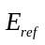) is compared to the solution of the Co-Simulation SPFD method (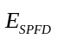) in terms of a plot of the relative error in the median plane of the human body model (Figure 6). It turns out, that the relative error for the maximum value of the electric field strength in this plane is about 7%.
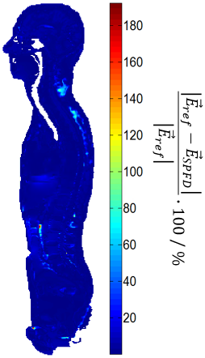
Fig. 6. Relative error of the body-internal electric field strength computed with the Co-Simulation SPFD method compared to a reference solution of a monolithic Scaled-Frequency FDTD simulation
The application of the Co-Simulation SPFD method for simulations of magneto-quasistatic IPT exposure scenarios requires less unknowns for the discrete problems, i.e., a reduced memory demand in comparison to the monolithic SF-FDTD simulation, as can be seen in Table I.

VI. Conclusion
A two-step approach for the simulation of the magneto-quasistatic human exposure - the Co-Simulation Scalar-Potential Finite Difference (SPFD) method - was developed and presented here. For the simulation of the exposure of high resolution human body voxel models the method was

implemented and performed on a multi-GPU high-performance workstation. An exposure simulation including models of an inductive power transfer (IPT) system and of a car was carried out.
Acknowledgement
This work is supported by the Deutsche Forschungsgemeinschaft (DFG) under grant number CL143/14-1.
References
[1] ICNIRP – International Commission on Non-Ionizing Radiation Protection, “Guidelines for limiting exposure to time-varying electric and magnetic fields (1 Hz-100 kHz),” Health Physics, vol. 99, no. 6, pp. 818-836, 2010.
[2] P. P. Ding, L. Bernard, L. Pichon, and A. Razek: “Evaluation of Electromagnetic Fields in Human Body Exposed to Wireless Inductive Charging System”, IEEE Transactions on Magnetics, vol. 50, no. 2, 2014.
[3] T. W. Dawson, J. de Moerloose, and M. A. Stuchly, “Comparison of magnetically induced ELF fields in humans computed by FDTD and scalar potential FD codes,” ACES J., vol. 11, pp. 63-71, Nov. 1996.
[4] O. P. Gandhi and J.-Y. Chen, "Numerical dosimetry at power-line frequencies using anatomically-based models," BioEM Suppl. I, pp. 43-60, 1992.
[5] C. Cimala, M. Zang M. Clemens, J. Feng, B. Schmuelling, and J. Streckert, "Numerical Schemes for High-Resolution Dosimetry Simulations of Automotive Low Frequency Inductive Power Transfer Systems," Proc. of the ICEAA IEEE-APS 2015, Torino, Italy, 07.-11.09.2015, pp. 1044 - 1047.
[6] T. W. Dawson and M. A. Stuchly, “Analytic validation of a threedimensional scalar-potential finite-difference code for low-frequency magnetic induction,” ACES J., vol. 11, pp. 72–81, Nov. 1996.
[7] R. Scorretti, N. Burais, L. Nicolas, and A. Nicolas, “Modeling of induced current into the human body by low-frequency magnetic field from experimental data,” IEEE Trans. Magn., vol. 41, no. 5, pp. 1992–1995, May 2006.
[8] A. Barchanski, M. Clemens, H. De Gersem, T. Steiner, and T. Weiland, “Using domain decomposition techniques for the calculation of low‐frequency electric current densities in high-resolution 3D human anatomy models,” COMP., vol. 24, no. 2, 2005.
[9] A. Barchanski, M. Clemens, E. Gjonaj, H. De Gersem, and T. Weiland, “Large-Scale Calculation of Low-Frequency-Induced Currents in High-Resolution Human Body Models,” IEEE Transactions on Magnetics, vol. 43, no. 4, 2007.
[10] R. Albanese and G. Rubinacci, “Magnetostatic field computations in terms of two-component vector potentials,” Int. J. Num. Meth. Eng., vol. 29, pp. 515–532, 1990.
[11] T. Weiland, “Time domain electromagnetic field computation with finite difference methods,” Int. J. Numer. Model. ENDF, vol. 9, pp. 259-319, 1996.
[12] C. Richter, S. Schöps, and M. Clemens, "Multi-GPU acceleration of algebraic multigrid preconditioners for elliptic field problems,“ IEEE Transactions on Magnetics, vol. 51, no. 3, 2015.
[13] A. Christ, W. Kainz, E. G. Hahn, et al., „The virtual family -development of surface-based anatomical models of two adults and two children for dosimetric simulations,” Phys. Med. Biol., vol. 55, no. 2, pp. N23–N38, 2010.
[14] CST AG, Bad Nauheimer Straße 19, 64289 Darmstadt, Germany.

